Fast Track Program
17 Weeks

Lose up to 75 Pounds
  - 17 Online Nutritional Counseling Support
  - 10 Weeks of Medication (2.5 months)
  - 6 Provider Visits
  - 34 Lipo Plus Injections
  - 1 Diet Panel
  - 2 Rounds of 23 HCG Injections

HCG Starter Kit Included
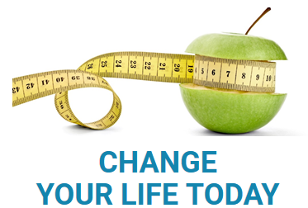

Retail Price $2,472.00

Sales Tax $5.58

